Nombre:__________________________ Hora: _____
DOL Week 12: Conjugating AR/ER/IR Verbs
*********** Due at the end of class Tuesday********
REGULAR SPANISH VERBS
When a Spanish word ends in AR, ER or IR it means it’s a verb. For example: Nadar means ‘to swim’ or Querer means ‘to want’.
You can leave the verb as is, if you put a different verb in front. For example: “I like to swim. Me gusta nadar.” OR “I’m going to learn Spanish. Voy a aprender el español.”
If you want to say who is doing the action, however, then you have to change the ending of the verb. For example: “I swim everyday. Yo nado todos los dias.” OR “We want cake now! ¡Queremos pastel ahora!”
AR verbs end in –ar, like patinar, nadar and hablar. ER verbs end in –er, like correr, querer and leer. IR verbs end in –ir, like escribir, vivir and ir. Each verb has a slightly different ending to attach depending who who’s doing the action.
STEP 1: Who is doing the action? Who is painting or swimming or needing something?
STEP 2: Take off the last two letters of the verbs to find the stem. For example: Hablar becomes Habl-. Correr becomes Corr-. Escribir becomes Escrib-.
STEP 3: Memorize the different verb endings for AR/ER/IR verbs and add the ending for the person that’s doing the action. Yo Hablar Yo Hablo. I to talk I talk.
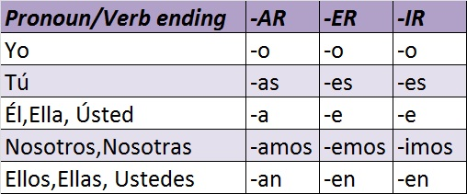

-AR VERB PRACTICE
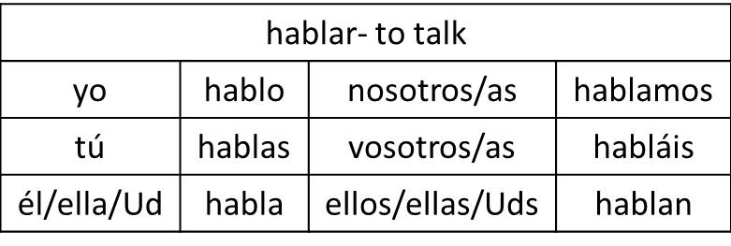
necesitar – to need
yo |  | nosotros/as
tú |  | vosotros | necesitáis
Él/ella/ud |  | Ellos/ellas/Uds.

practicar – to practice
yo |  | nosotros/as
tú |  | vosotros | practiques
Él/ella/ud |  | Ellos/ellas/Uds.

celebrar – to celebrate
yo |  | nosotros/as
tú |  | vosotros | celebráis
Él/ella/ud |  | Ellos/ellas/Uds.

estar – to be (temporary)
yo | estoy | nosotros/as
tú |  | vosotros | estáis
Él/ella/ud |  | Ellos/ellas/Uds.

1. Yo _________ un lápiz. I need a pencil.
2. ¿Cómo ______? How are you?
3. _________ para la clase de música. We practice for band.
4. No _________ el Halloween. She doesn’t celebrate Halloween.
5. ____________ hacer unos cambios. We need to make some changes.
6. Me gusta __________ deportes. I like to practice sports.
7. Juan y Juanita ________ la Navidad. John and Johana celebrate Christmas.

ER/IR Practice
-ER VERB PRACTICE
decidir – to decide
yo |  | nosotros/as
tú |  | Vosotros | decidís
Él/ella/Ud. |  | Ellos/ellas/Uds.
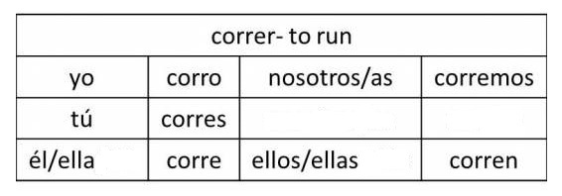
leer – to read
yo |  | nosotros/as
tú |  | vosotros | leéis
Él/ella/Ud. |  | Ellos/ellas/Uds.

aprender – to learn
yo |  | nosotros/as
tú |  | vosotros | aprendéis
Él/ella/Ud. |  | Ellos/ellas/Uds.

deber – to owe
yo |  | nosotros/as
tú |  | vosotros | debéis
Él/ella/Ud. |  | Ellos/ellas/Uds.

barrer – to sweep
yo |  | nosotros/as
tú |  | vosotros | barréis
Él/ella/Ud. |  | Ellos/ellas/Uds.

1. ¿Tú__________ Harry Potter? You read Harry Potter?
2. ¡Oye, ese cuate me ________ dinero! Hey, that dude owes me money!
3. Vamos a _________ el aula para Ud., Señora deAlba. We’re going to sweep the classroom for you, Mrs. DeAlba.
4. Guao, ellos __________ rápido. Wow, they run fast.
5. __________ nuestro éxito a la preparatoria Harrison. We owe our success to Harrison High School.
6. ¿___________ mucho en la clase de historia? You guys learn much in history class?
7. Sí, nosotros __________ un montón en la clase de historia. Yeah, we learn a ton in history class.

-IR VERB PRACTICE
escribir – to write
yo | escribo | nosotros/as | escribimos
tú | escribes | Vosotros | escribís
Él/ella/Ud. | escribe | Ellos/ellas/Uds. | Escriben

vivir – to live
yo |  | nosotros/as
tú |  | Vosotros | vivís
Él/ella/Ud. |  | Ellos/ellas/Uds.

abrir – to open
yo |  | nosotros/as
tú |  | Vosotros | abrís
Él/ella/Ud. |  | Ellos/ellas/Uds.

1. Yo __________ un poema para mi amor. I write a poem for my love.
2. Ella ________ una puerta en mi corazón. She opens a door in my heart.
3. ________ para escuchar su voz. I live to hear her voice.
4. Cada amanecer __________ enamorarse otra vez. Every dawn we decide to fall in love again.
5. Beso por beso, ______________ nuestra historia. Kiss by kiss, we write our story.
6. No _________ nuestro futuro. They do not decide our future.
7. __________ para siempre en este abrazamiento! We live on forever in this embrace!

